Sierpinski carpet
-carpet which is being made by the thousands of children worldwide.

This fractal is described for the first time by the Waclaw Sierpinski in 1916. It starts with square (zero iteration) which is divided than in nine equal squares (each side is 1/3 of the original). Square in the middle is subtracted (first iteration) and procedure is repeated with eight squares that are left. As a result of iteration infinity we have Sierpinski carpet.

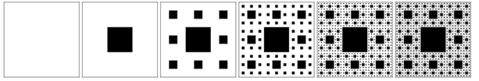

Year 2016 is 100th anniversary since Sierpinski described this fractal, and since it is anniversary year it is planned that in this year project Sierpinski carpet ends. This project includes construction of Sierpinski carpet of seventh iteration, which will be 43, 74 meters, and will consist of 512 smaller carpets of fourth iteration.
“Sierpinski Carpet Project” is not profitable project activity which brings closer children from all over the world, who are going to make this gigantic carpet geometrical fractal out of stickers, which is named Sierpinski carpet.
Authors of this project are Jose Luis Rodriguez Blancas professor at the University in Almeira (Spain) and David Crespo Casetleiro (in charge for secondary schools).
Currently there are more than 640 carpets which are being made in 41 country, and by 40960 children.
Our pupils 7th grade (a & b), together with their teacher Ms. Marija Raič Raguž, and pupils of the 1st grade (b) with their teacher Ms. Katica Vladimir have joined this project, and will participate in creation of this gigantic fractal.
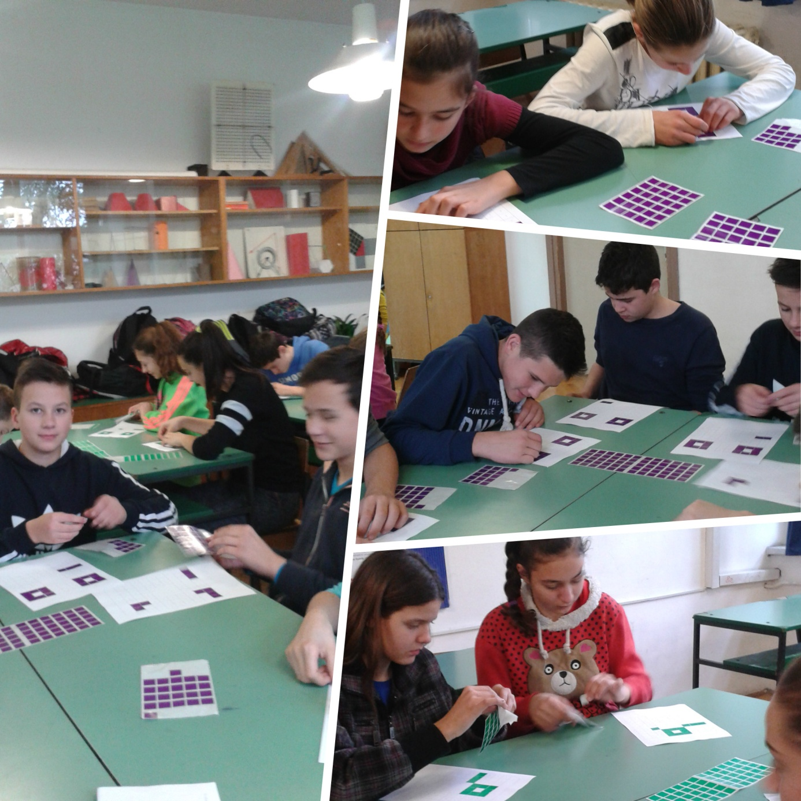
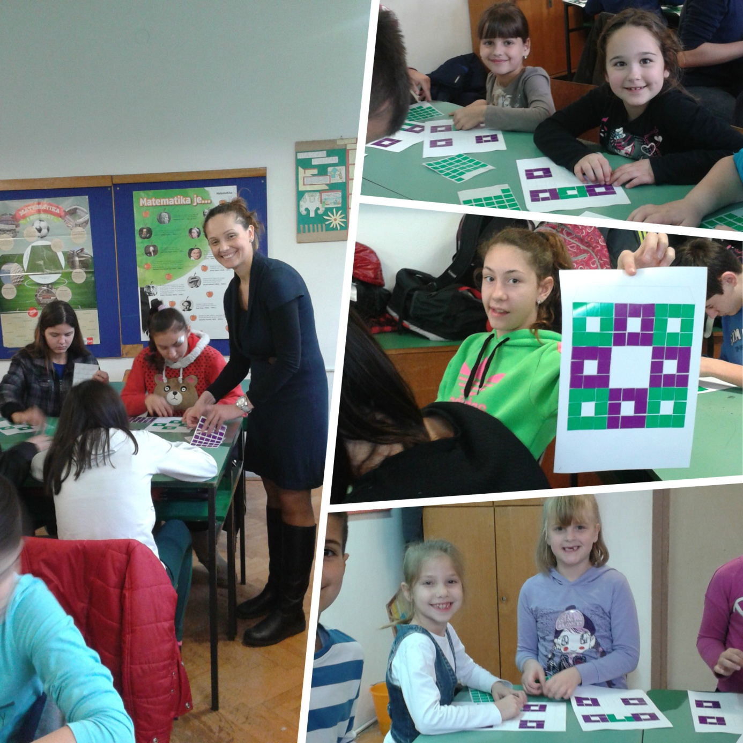
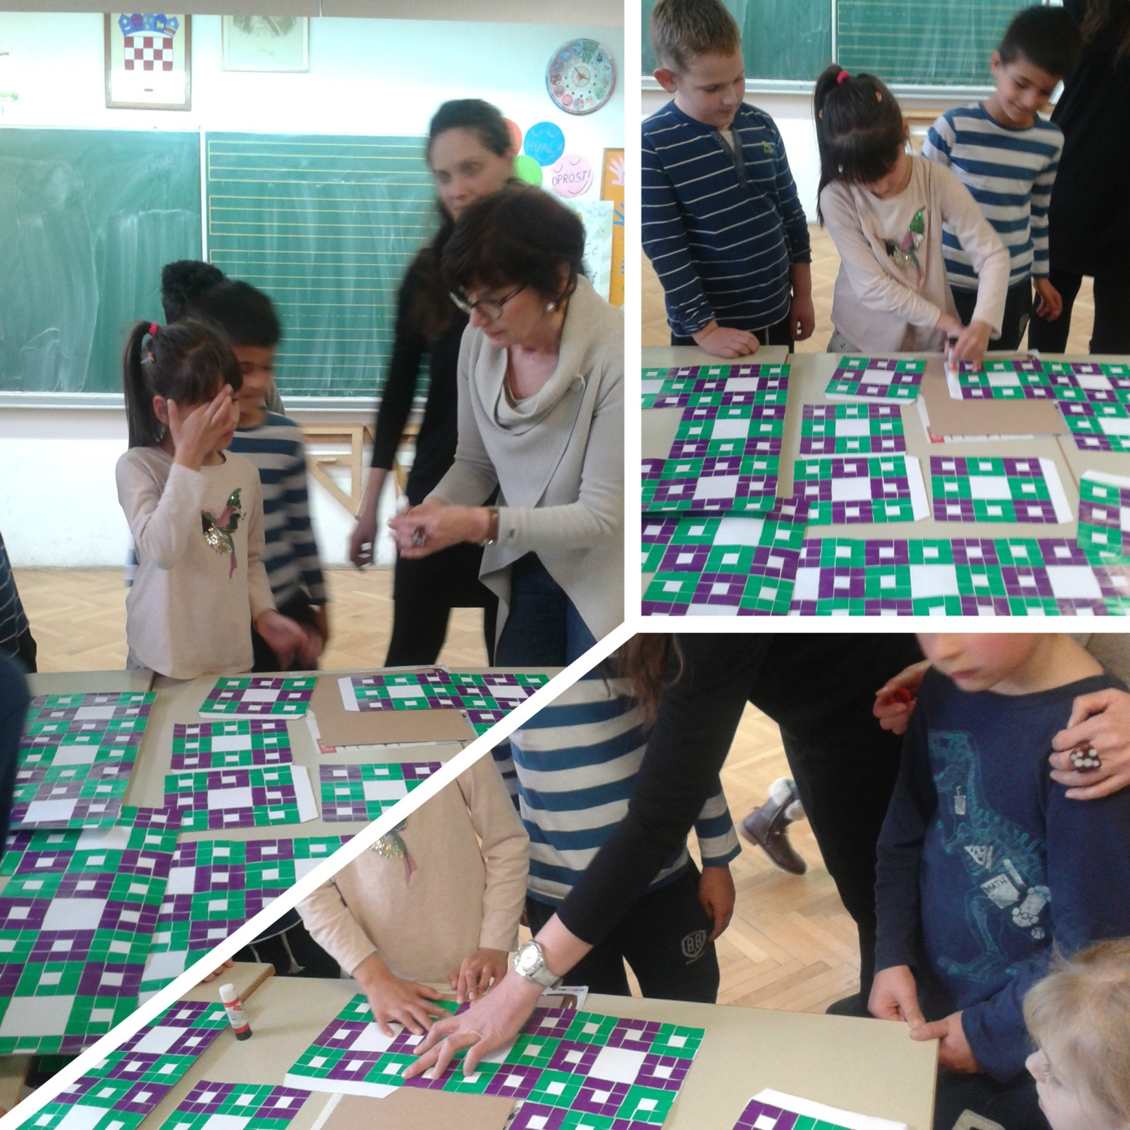
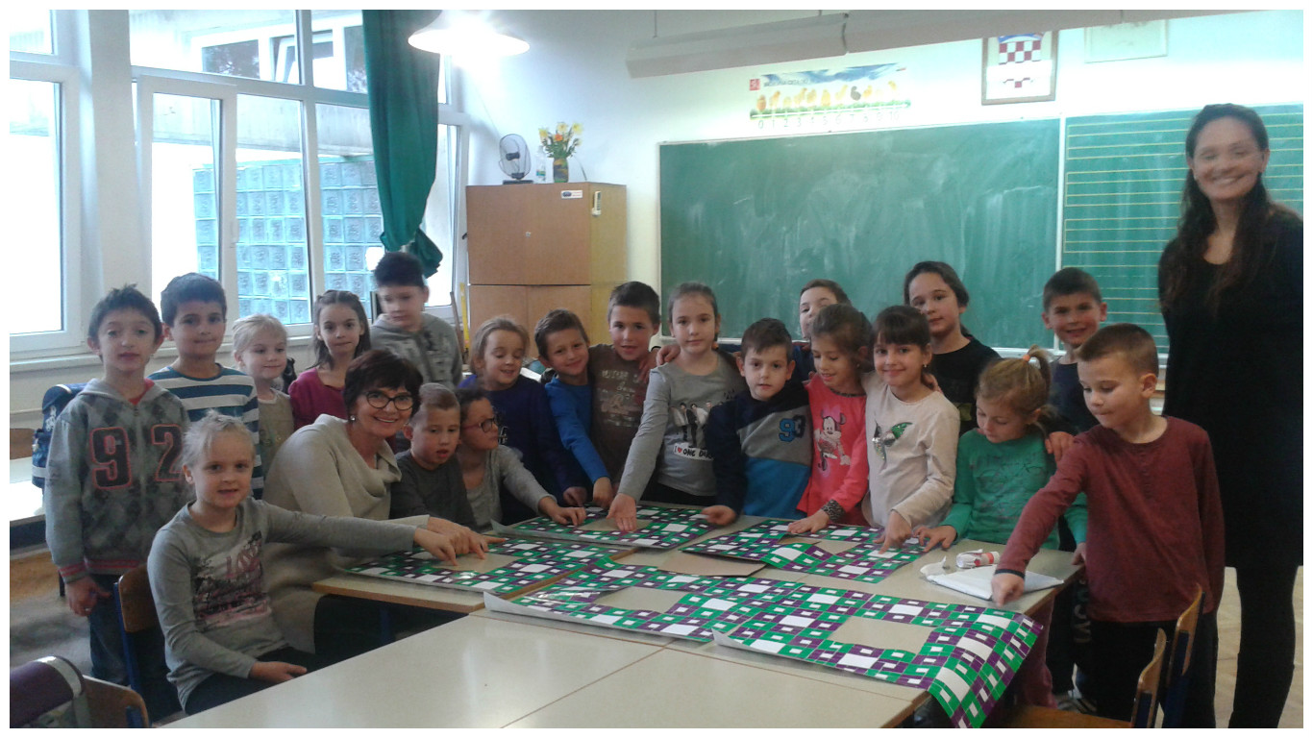
Our carpet is carpet no. 384.
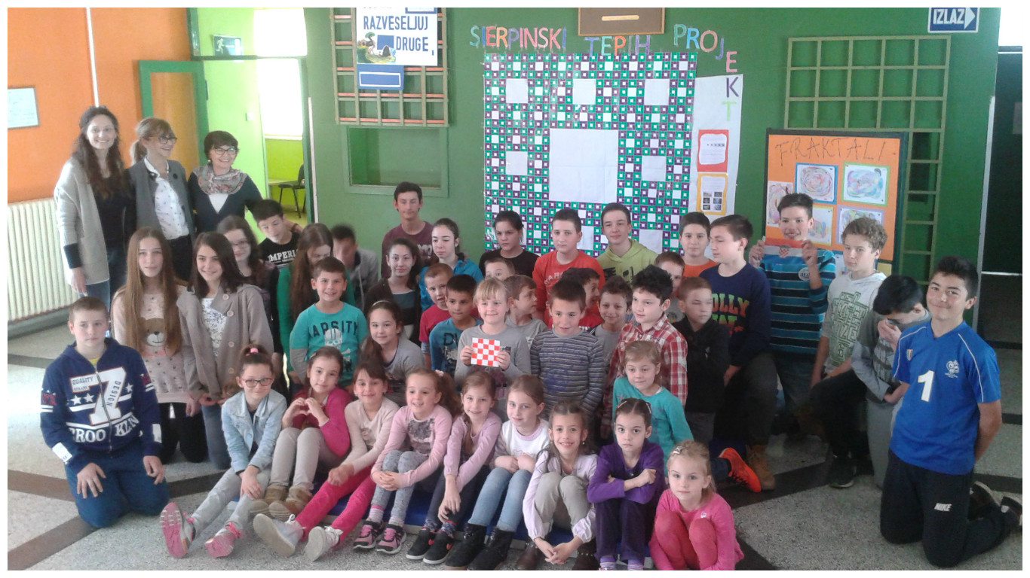
While we were working on this project , pupils had chance to discover variety of fractals in nature, what fractal is, and how are created.
All were part of a workshop “Nature, the most powerful creator”, where they taught about fractals in nature (plants, broccoli, cauliflower, crystallized honey, orange, pine tree etc..)
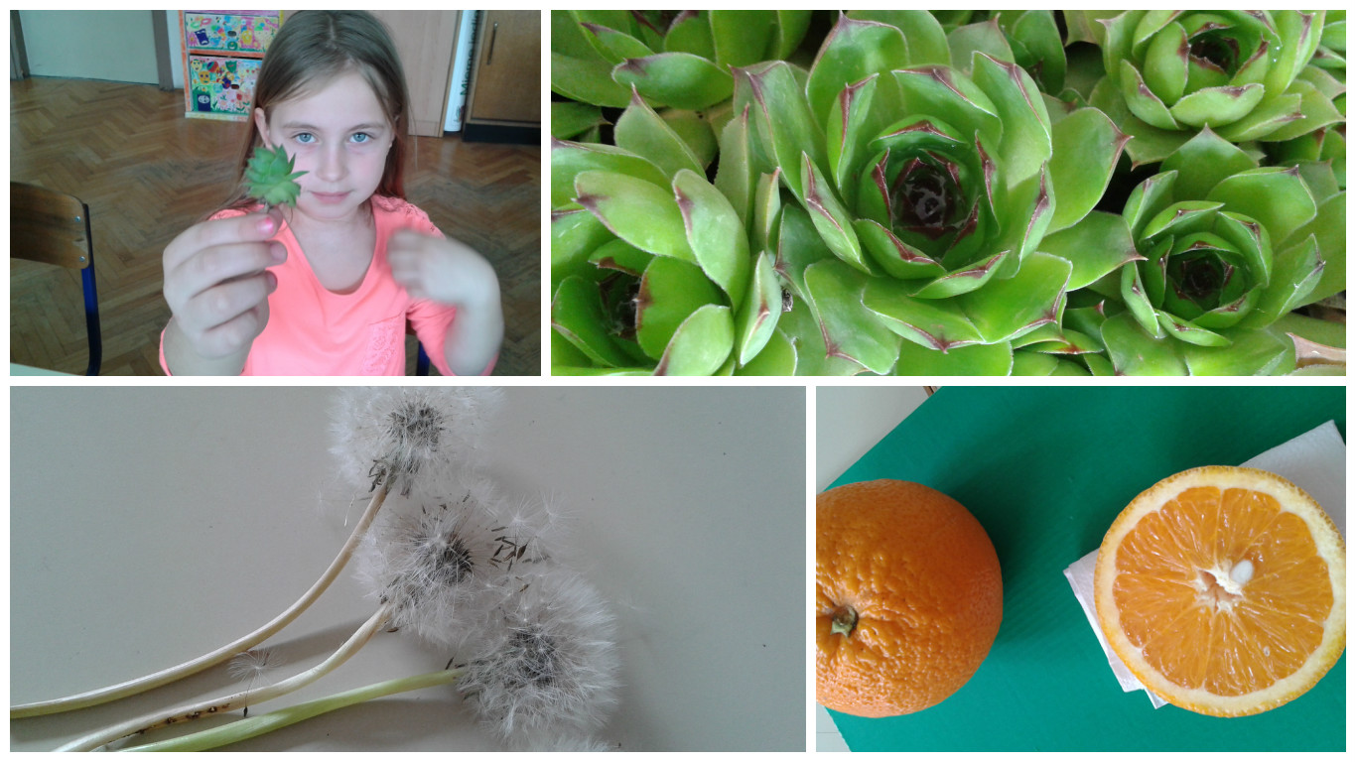
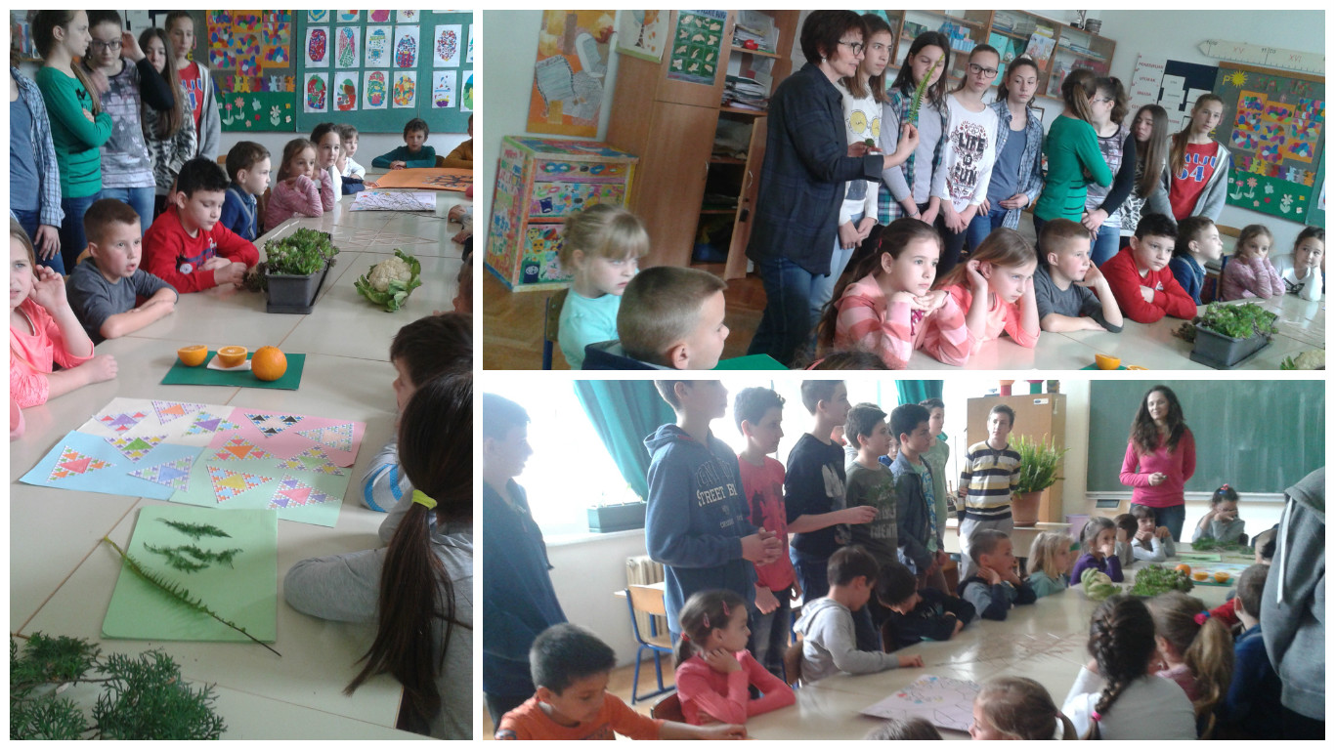
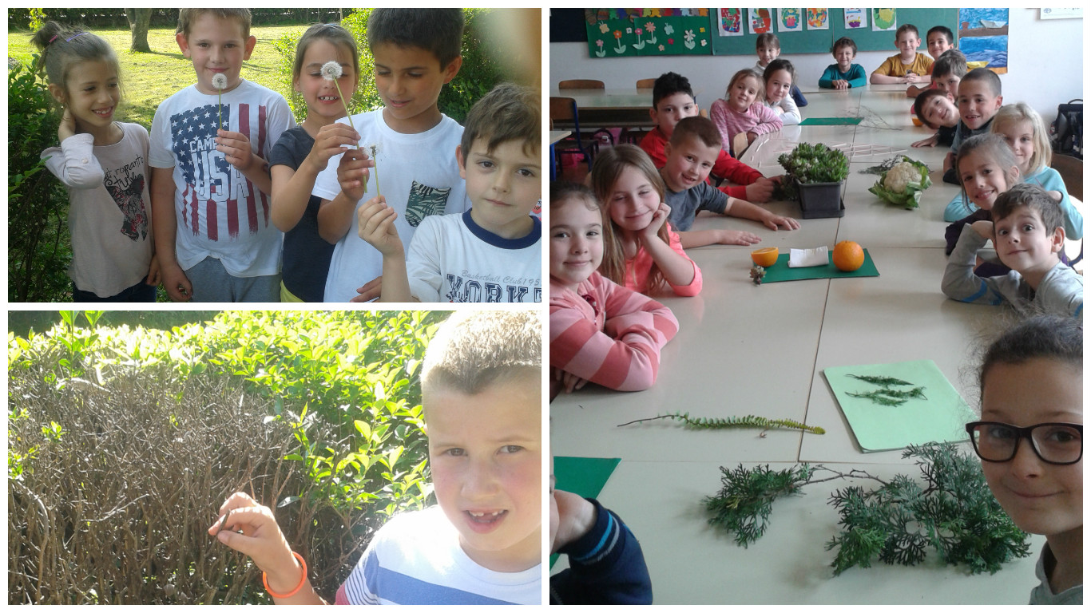
Pupils have been taught that fractals are geometrical shapes which are not specified in dimension and in their smallest part are the same as
During Art & Design classes pupils of the first grade were drawing Art-fractals with usage of the special techniques. They were very excited, and happy.
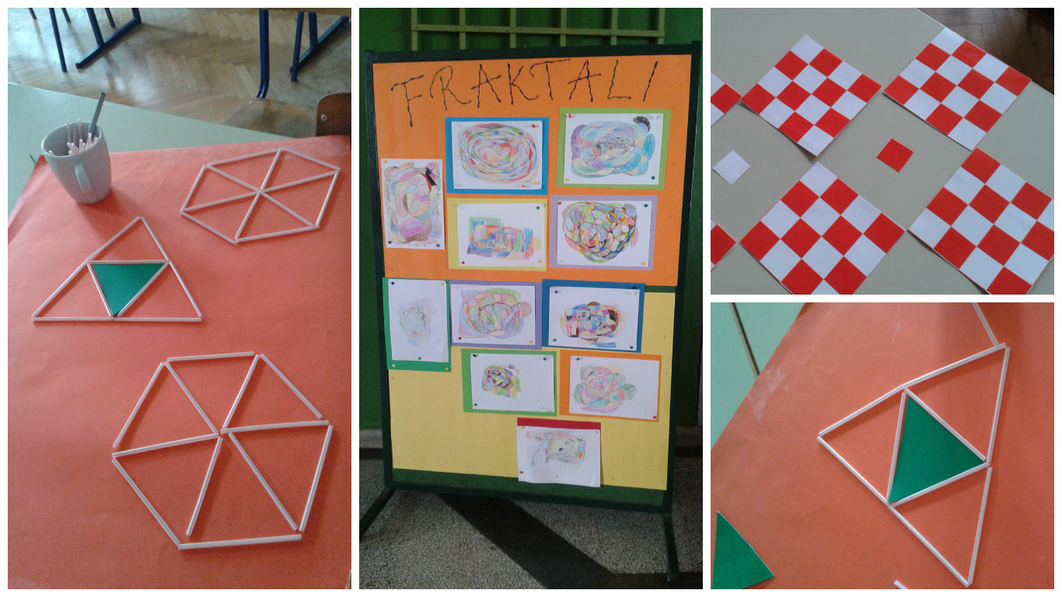

Pupils of the 7th grade were constructing, and colouring Sierpinski triangle, focusing on similar triangles in their surface.
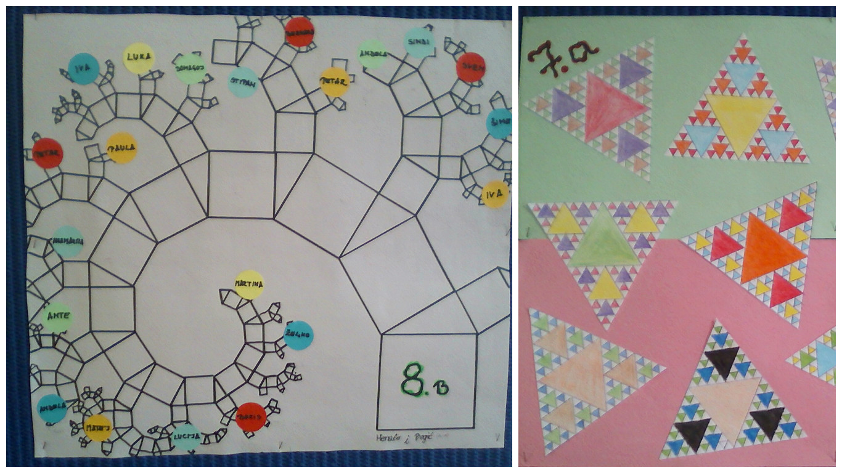

Pupils of 8th grade were drawing Pythagoras tree (symmetrically and asymmetrically), constructing triangles according to Tales, and calculating their sides according to Pythagoras rule.
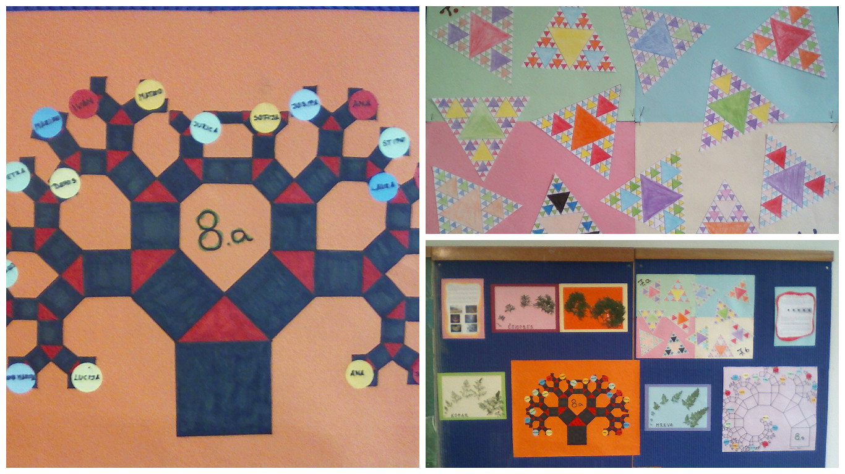
Also they were looking for fractals in their garden and in the surrounding. Everything they have collected was exhibited in the hall of the school and in the classrooms.
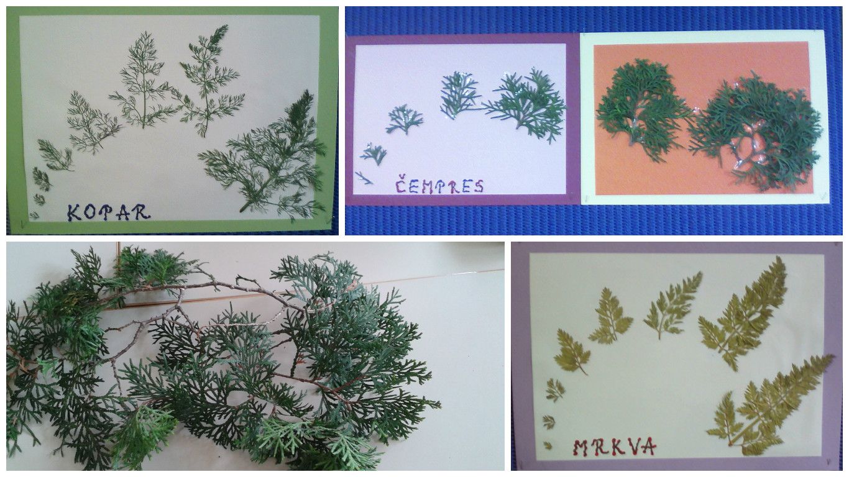
Pupils have participated in this international project, had great time, gained knowledge, and realised that Mathematics can be creative and fun.
